**Chain drugstore Management**

* **ER DiagramDiagram

  Description automatically generated**
* **Relational schemaDiagram

  Description automatically generated**
* **Chain Pharmacy table**

create table chain_pharmacy

( store_id int primary key,

pharmacy_name varchar(100),

phone bigint,

address varchar(200),

M_id int , Areas varchar(50));

insert into chain_pharmacy values (101, "CVS pharmacy",02224092234,"741 W 31ST",1001,"741 W 31ST");

insert into chain_pharmacy values (102, "WALGREENS #09038",02224092534,"4001 W IRVING PARK RD",2002,"4001 W IRVING PARK RD");

insert into chain_pharmacy values (103, "GSK PHARMACY INC",02224092584,"5140 W CHICAGO AVE",3002,"5140 W CHICAGO AVE");

insert into chain_pharmacy values (104, "SAVE RITE PHARMACY DISCOUNT CENTER",02224095584,"3479 N BROADWAY ST",4002,"53479 N BROADWAY ST");

insert into chain_pharmacy values (105, "PROFESSIONAL OFFICE BUILDING PHARMACY",02224095584,"1725 W HARRISON STE 418",5002,"1725 W HARRISON STE 418");

insert into chain_pharmacy values (106, "111th Pharma Family",02224095544,"11101 S STATE ST",5002,"11101 S STATE ST");

insert into chain_pharmacy values (107, "MARIAM PHARMACY",02224095524,"3514 W Lawrence Ave",7002,"3514 W Lawrence Ave");

insert into chain_pharmacy values (108, "OSCO DRUG",02224096524,"1763 W Howard St",8002,"1763 W Howard St");

insert into chain_pharmacy values (109, "Dr. Z's Pharmacy",02224086524,"4326 N Lincoln Ave",9002,"4326 N Lincoln Ave");

insert into chain_pharmacy values (110, "DAMBER PHARMACY",02224046524,"213 W INSTITUTE PLACE STE 703",1002,"213 W INSTITUTE PLACE STE 703");

select * from chain_pharmacy;

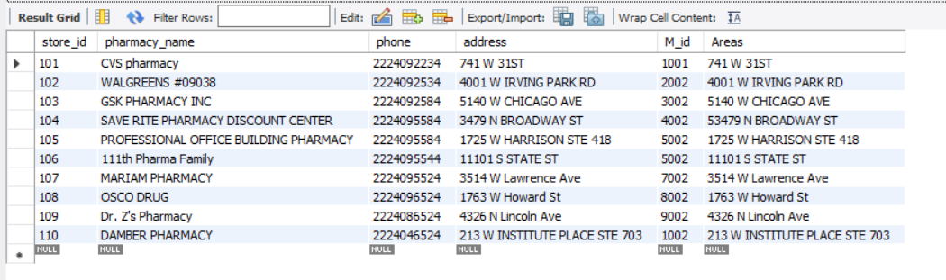

* **Drug table**

create table Drugs

( drug_id int primary key,

d_name varchar(100),

price decimal, sale_price int,

icon varchar(20),

company varchar(50),

package char(2),

weight varchar(8),

remark varchar(50),

safety_stock int);

insert into Drugs values(201,"ACEBROTE Tablet",80,120,"Cipla Ltd (Generics)","CIPLA INDIA","NM","200gm","Chills and Fever",100);

insert into Drugs values(202,"Clopicard Tablet",60,89,"Cipla Ltd (Generics)","CIPLA INDIA","NM","75mg","Rashes",50);

insert into Drugs values(203,"METFOR Tablet",20,24,"Cipla Ltd (Generics)","CIPLA INDIA","NM","500mg","Loss of Appetite",130);

insert into Drugs values(204,"Dericip Tablet",2,3,"Cipla Ltd (Generics)","CIPLA INDIA","NM","77mg","Headache",10);

insert into Drugs values(205,"Nicip Tablet",50,77,"Cipla Ltd (Generics)","CIPLA INDIA","NM","375mg","Vomiting",100);

insert into Drugs values(206,"Cephadex 500mg Capsule",100,142,"Cipla Ltd (Generics)","CIPLA INDIA","NM","500mg","Stomach Pain",80);

insert into Drugs values(207,"Roxee Tablet",80,120,"Cipla Ltd (Generics)","CIPLA INDIA","NM","150mg","Nausea",120);

insert into Drugs values(208,"Tercan M Gel ",90,116,"Cipla Ltd (Generics)","CIPLA INDIA","NM","10gm","Skin Peeling",50);

insert into Drugs values(209,"Lipvas Tablet",100,133,"Cipla Ltd (Generics)","CIPLA INDIA","NM","20mg","Joint Pain",10);

insert into Drugs values(210,"VOMISTOP Tablet",10,24,"Cipla Ltd (Generics)","CIPLA INDIA","NM","10mg","Dry Mouth",15);

select * from Drugs;

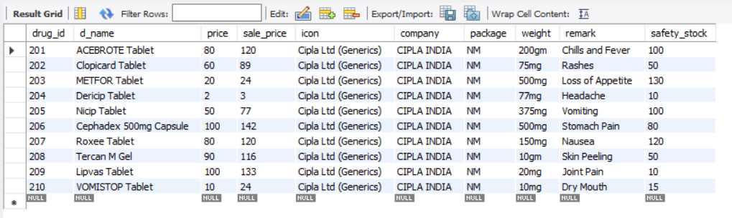

* **Plan table**

create table Plan

(

plan_id int primary key,

plan_time Datetime,

quantity int,

price decimal,

T_price decimal,

drugs_id2 int,

store_id2 int,

Foreign key (drugs_id2) references Drugs(drug_id),

Foreign key (store_id2) references chain_pharmacy(store_id));

insert into Plan values(301,current_time(), 200,120,24000,201,101);

insert into Plan values(302,current_time(), 100,89,8900,202,101);

insert into Plan values(303,current_time(), 300,24,7200,203,102);

insert into Plan values(304,current_time(), 1000,3,3000,204,103);

insert into Plan values(305,current_time(), 400,77,30800,205,105);

insert into Plan values(306,current_time(), 200,142,28400,206,104);

insert into Plan values(307,current_time(), 150,120,18000,207,106);

insert into Plan values(308,current_time(), 200,116,23200,208,107);

insert into Plan values(309,current_time(), 100,133,13300,209,108);

insert into Plan values(310,current_time(), 1000,24,24000,210,110);

select * from Plan;

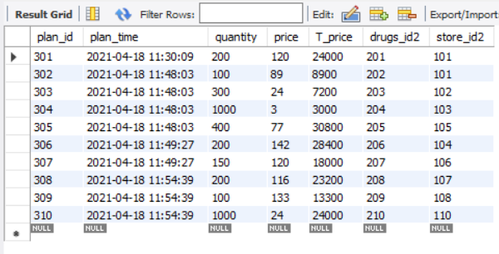

* **Sale table**

create table Sale

(

sale_id int primary key,

sale_date datetime,

quantity int,

price decimal,

sale_money decimal,

drugs_id3 int,

store_id3 int,

employee_id2 int,

Foreign key (drugs_id3) references Drugs(drug_id),

Foreign key (store_id3) references chain_pharmacy(store_id),

Foreign key (employee_id2) references employee(E_id));

insert into Sale values(401,current_date(), 200,120,24000,201,101,601);

insert into Sale values(402,current_date(), 100,89,8900,202,101,601);

insert into Sale values(403,current_date(), 300,24,7200,203,102,603);

insert into Sale values(404,current_date(), 1000,3,3000,204,103,602);

insert into Sale values(405,current_date(), 400,77,30800,205,105,604);

insert into Sale values(406,current_date(), 200,142,28400,206,104,605);

insert into Sale values(407,current_date(), 150,120,18000,207,106,604);

insert into Sale values(408,current_date(), 200,116,23200,208,107,602);

insert into Sale values(409,current_date(), 100,133,13300,209,108,603);

insert into Sale values(410,current_date(), 1000,24,24000,210,110,604);

select * from Sale;

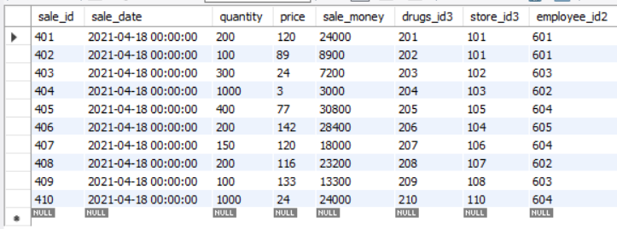

* **Stock table**

create table stock

(

stock_id int primary key,

stock_date datetime,

last_remain int,

were int,

sale_num int,

remaains int,

isable char(10),

drugs_id4 int,

Foreign key (drugs_id4) references Drugs(drug_id));

insert into stock values (701, current_date(), 10000, 100000, 4000, 200, 20000, 201);

insert into stock values (702, current_date(), 20000, 10000, 3000, 300, 40000, 202);

insert into stock values (703, current_date(), 10000, 100000, 4000, 200, 20000, 202);

insert into stock values (704, current_date(), 10000, 100000, 4000, 200, 20000, 203);

insert into stock values (705, current_date(), 10000, 100000, 4000, 200, 20000, 204);

insert into stock values (706, current_date(), 10000, 100000, 4000, 200, 20000, 205);

insert into stock values (707, current_date(), 10000, 100000, 4000, 200, 20000, 206);

insert into stock values (708, current_date(), 10000, 100000, 4000, 200, 20000, 207);

insert into stock values (709, current_date(), 10000, 100000, 4000, 200, 20000, 208);

insert into stock values (710, current_date(), 10000, 100000, 4000, 200, 20000, 209);

select * from stock;

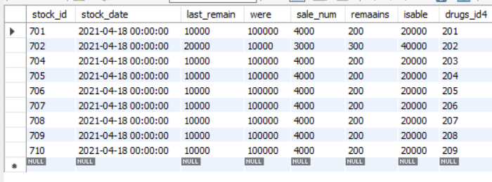

* **Employee table**

create table employee

(

E_id int primary key,

E_Name varchar(50),

E_number bigint);

insert into employee values (601,"Jashraj",12345);

insert into employee values (602,"Aniket",123456);

insert into employee values (603,"Harsh",1234567);

insert into employee values (604,"Soham",12345678);

insert into employee values (605,"Jashraj",123456789);

select * from employee;

